**License checking and vehicle verification**

MD. RIFAT ANWAR, Department of CSE, KUET

Amit Hasan Rony, Department of CSE, KUET

Prottoy Saha, Lecturer, Department of CSE, KUET

***Abstract –* Now a day’s increasing population has become a major threat in our country. As a consequence, the number of unlicensed vehicles, unlicensed drivers, unauthorized drivers, stolen vehicles are increasing at an alarming rate. As a result, the administration of BANGLADESH is facing challenges to maintain, reduce or remove the unlicensed vehicles, stolen one’s and catch up the drivers who don’t have the right to drive. Sometimes drivers also forget to keep vehicle papers and insurance paper with them. This paper proposes a solution which will automate the license checking process of drivers, the vehicles, identify the stolen or unauthorized one’s and gives the drivers an easy solution than carrying vehicle and insurance papers with them. Our proposed system will have a database of transportation and drivers that will be maintained by ‘*Bangladesh Road Transport Authority*’ (BRTA). Using the database our system will automate the license and vehicle checking process which will assist the traffic police and if it finds an unauthorized one, then civil police will be informed of that.**

1. ***Introduction***

Bangladesh Road Transport Authority (BRTA) is a Bangladesh government bureau responsible for registering vehicles, giving license to vehicles and drivers and also in insurance issue. At present they give all the documents to the vehicle owners as hard copy. Sometimes vehicle owners forget to bear such important papers related to their vehicles in the time of inquiry.

This paper introduces a solution in such cases. First of all, the vehicle owners are provided with a digital vehicle card (in our project purpose we used RFID cards) and also digital license card. The vehicle owner only needs to carry these two cards with them while driving. Secondly, the vehicle owners and the authorized administration can have any information regarding the vehicle using a website.

The website will be run by the BRTA authority to keep the information of registration of a vehicle, owner’s personal information, insurance date of the applier, registration date etc. The BRTA authority will only have the authority to update it.

This paper proposed that firstly there will be some stoppage point in the road. In the point, we have an automated license checker machine for the vehicles and drivers. Vehicles come to the point, stops. Then drivers will give the digital car card and license card in the scanner (for project purpose RFID scanner is used) and to detect the license card that is scanned is the card of the driver, we use a fingerprint scanner machine which will match the fingerprint with the fingerprint information found by scanning the license card. It will ensure that no person can use fake or other driver’s license card. At least the driver must be present there. Our system will take the car number, retrieve information from BRTA database and matches it with the information found after scanning the digital vehicle card. Civil

police will have the authority to request the BRTA authority to have information about any stolen vehicle and ask them to update that vehicle in the database as stolen ones. If the scanned vehicle card matches with the stolen ones or the scanned information of vehicle card and information found using car number does not match or any issue of fake or overdate license of the driver a bazar will ring up and the display of the system will show the issue. Then nearby civil police can take immediate action. Also, in case no nearby civil police, our system will store information of the vehicle, the license of the driver and update the time and date of coming it, in the database for further use. If all the information found correctly then the system will let the vehicle go.

Advantages of our system is that it will reduce the corruption occurs during vehicle checking and it will make life easier for both the authority and the owners and drivers of vehicles. It will also reduce stealing vehicles and will reduce the workload of the traffic police also.

1. ***System Design Architecture***

In this section the overall design architecture of our system will be discussed. To illustrate our system, we divide our system into three modules.

1. BRTA Authority module
2. Automated system module
3. Civil police module
4. *BRTA Authority module*

To make life simpler for the drivers and vehicle owners this paper introduces a website for BRTA authority. The applier will submit their hardcopy papers to BRTA authority for registration. BRTA authority will update the information in the database of the website and give the applier a digital vehicle card (In our project RFID card) which will be scanned by our automated system. For the application of driving license BRTA authority will also give a digital

scannable license card (In our project purpose, we used RFID card). This information will also be updated in the BRTA database. Civil police will have access to the BRTA website to request them to mark any vehicle as stolen ones or they can ask BRTA for information about any driving license or vehicle. So, in the BRTA database there exists three kind of information:

1. Vehicle information
2. Driving license information
3. Stolen vehicles information

We will discuss about all the three-information brief:

1. *Vehicle Information*

Vehicle information includes vehicle name, vehicle type, vehicle size, vehicle model number, vehicle number, vehicle insurance date, vehicle emission date, owner’s name, owner’s address, owner’s contact number, owner’s NID card number. This information will only be inserted or updated by the BRTA administration and our automated system has the access to it.

1. *Driving License Information*

This includes detail about the license holder and the vehicle type. Information like driver’s name, address, age, contact number, gender, date of birth (DOB), blood group, fingerprint, license issue date or date of issue (DOI), renewal date, expire date, license vehicle date. This information is updatable for BRTA and our automated system can retrieve or update this information.

1. *Stolen Vehicle Information*

In this section of the database includes information about stolen vehicles. Civil police will ask the BRTA authority to update their database with the information of stolen vehicle information. This includes information of stolen date, time, place, vehicle number, vehicle color, vehicle owner’s information will also be inserted.

The figure FIG 1.1 will illustrate the BRTA authority module briefly:

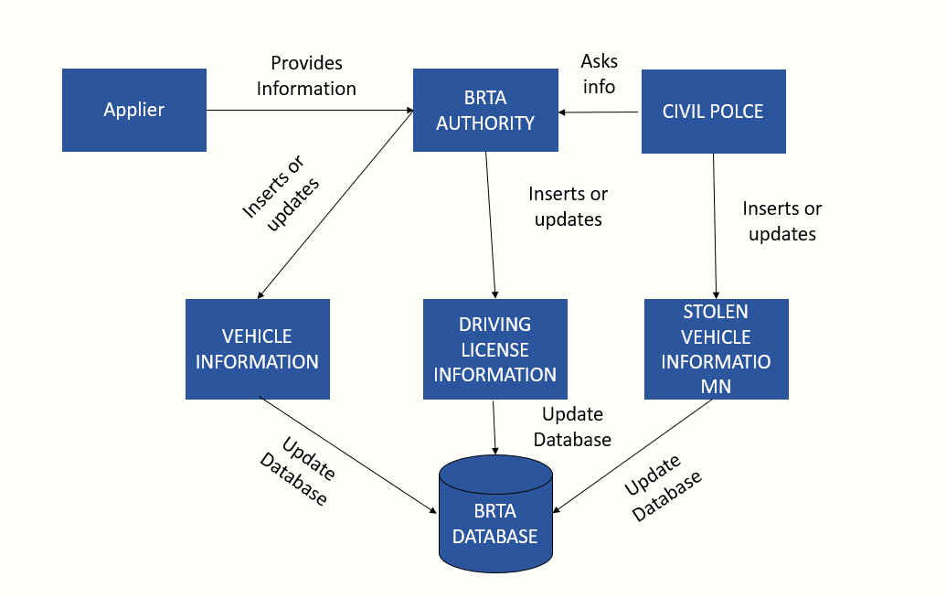

Figure 1.1: BRTA authority working process

1. *Automated system module*

This module mainly works on vehicle and driver validity checking. The main focuses on:

1. Vehicle card checking
2. License checking of drivers
3. Scanning fingerprint
4. Matching fingerprint with information from license card
5. Matching vehicle card with the retrieved information from vehicle number
6. Display system
7. Buzzer system
8. *Vehicle card checking*

When any vehicle come the stoppage point, drivers or owner of vehicles have to scan their provided vehicle

card in the scanner of our automated system. Our system will scan the card and gain required information from BRTA database. Then the display will tell to put the license card in the scanner.

1. *License checking for drivers*

The driver will be asked to scan his/her license card in the scanner. After scanning, our system will gain the required information from BRTA database along with the fingerprint of the scanned license.

1. *Scanning fingerprint*

After scanning the license card, the driver will be asked through display to keep his/her registered finger on the fingerprint scanner. If fails, then system will ask again. After 5 times the system will be reset, and the total scanning process will be repeated.

1. *Matching fingerprint with information from license card*

When fingerprint is stored in our system, it will match the fingerprint with the fingerprint found from BRTA database using the license card.

1. *Matching vehicle card with the retrieved information from vehicle number*

The system will take the vehicle number as input, retrieve information of the vehicle from the BRTA database and will match it to the information found from the vehicle card.

1. *Display system*

A display system is included in our system to guide the drivers of the vehicle coming to the stoppage point of our system. This will show the status of vehicle card, license card and fingerprint checking and will give the permission to move on if all the information is valid. Otherwise it will show the cause of failure.

1. *Buzzer system*

When the license checking process is finished, if the vehicle passes through all the tests by our system will

let the vehicle pass without ringing the buzzer. If stolen vehicle is detected the buzzer will ring up and the nearby civil police can take immediate action or they can get information about the vehicle later from our system as it would save that.

The figure Fig 1.2 will give the illustration of the automated system module.